HOOGHLY BRANCH (GOVT) SCHOOL EX-STUDENTS’ ASSOCIATION

About the Organization
The Hooghly Branch (Govt) School Ex-Students’ Association was established in 1996 at Chawk Bazar, Hooghly, West Bengal, to strengthen unity and fraternity among former and present students of Hooghly Branch (Govt) School. The association promotes physical, mental, educational, and cultural development and is registered under the Registrar of Societies, Government of West Bengal (Regn. No. S/93009).

Vision
To build a strong lifelong bond among alumni and current students while fostering educational excellence, social responsibility, cultural heritage, and holistic development.

Mission
• Strengthen unity and fraternity among ex- and present students.
• Promote physical, mental, educational, and cultural development.
• Encourage knowledge creation, exchange of ideas, and academic excellence.
• Support students through educational and social initiatives.

Major Activities
- Inter-school Quiz Competition
- Science Exhibition
- Free Health Camp
- Support for Higher Education
- Inter-school Music Competition
- Computer Education Mela
- Distribution of Prizes to Successful Students
- Blanket Distribution Camp
- Sit and Draw Competition
- Publication of Annual Souvenir
- Seminars
- Blood Donation Camp
- Football Coaching Camp
- Surajit Sengupta & Ashwini Barat Inter-School Invitational Football Tournament
- Anil Kumar Deb Memorial Scholarship

President Message
Dr. Partha Tripathi
Hooghly Branch Government School Ex-Students Association
It gives me immense pleasure and a deep sense of pride to welcome you all to the official launch of the website of the Hooghly Branch Government School Ex-Students Association.

This platform is not merely a digital presence; it is a living bridge connecting generations of students who have walked through the corridors of our beloved institution. Our school has not only imparted education but has shaped values, character, and a lifelong sense of belonging. Today, through this website, we reaffirm that bond and carry it forward into the future.

Our Association, founded in 1996, has now proudly stepped into its 30th year—a significant milestone that reflects decades of unity, shared memories, and collective commitment. Over the years, we have grown not only in numbers but also in purpose, strengthening the ties among alumni and contributing meaningfully to our alma mater and society.

Beyond fellowship, our Association has consistently engaged in a range of meaningful social initiatives. We have organized blood donation camps, conducted health check-up programs, and actively promoted thalassemia awareness to build a healthier community. Our efforts also extend to nurturing young minds through health quizzes among students, encouraging awareness and scientific curiosity. Recognizing the importance of education and equity, we take pride in awarding scholarships to needy and deserving students, supporting them in their journey towards a brighter future.

In an era driven by connectivity and information, this initiative aims to bring together alumni across different years, professions, and geographies onto a single, vibrant platform. It will serve as a repository of memories, a network for collaboration, and a channel for meaningful engagement. Whether it is sharing achievements, organizing events, mentoring young students, or contributing to the development of our institution, this website will be a catalyst for collective growth.

Our Association has always stood for unity, service, and commitment to excellence. With this digital step, we aspire to strengthen these ideals further. We envision a dynamic space where past meets present, where experience guides aspiration, and where every member feels connected and valued.

I sincerely thank all members, contributors, and well-wishers whose efforts and dedication have made this initiative possible. I also invite all alumni to actively participate, enrich this platform, and help us build a stronger, more connected community.

Let this website be not just a source of information, but a symbol of our shared heritage and a beacon for future endeavors as we celebrate this landmark 30th year together.

Bank Details
Name-Hooghly Branch (Govt.) School Ex-Students Association.
Bank & Branch Name-State Bank of India, Chinsurah Branch
Account No.00000042708543555, IFSC : SBIN0000056,PAN : AAAAH0494E
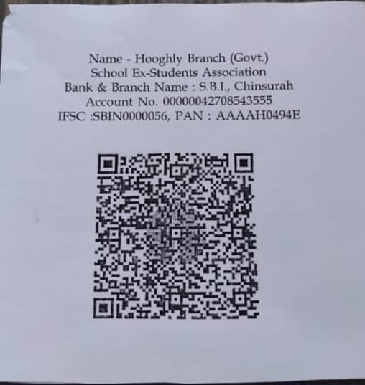

Executive committee of Hooghly Branch (Govt.) School Ex-students Association for 2026-27
Convenor- Dr. Debasis Sanyal
President- Dr. Partha Tripathi.
Vice Presidents- 1)Sudarshan Roy, 2)Dr.Subir Mukherjee.
Secretary- Subrata Datta.
Treasurer- Probodh Boral
Coordinator- Mirajul Mojahar.
Reunion Sub-committee- 1) Sekhar Roy, 2) Asim Das.
Sports Sub-Committee- 1) Sarbajit Sengupta, 2) Tirtha Pratim Mitra.
Reception & Souvenir Sub-committee- 1) Shuvadip Adhikari, 2) Sounak Banerjee.
Cultural sub-committee- 1) Dr. Soumitra Narayan Sur, 2) Sandip Chatterjee.
E-governance- Joydeep Roychoudhury

